# How old is the moon?

Table of Contents

How old is the moon? 1

Abstract 2

1. Introduction 2

2. Theory 2

3. Method 4

4. Results 8

5. Discussion 9

6. Conclusion 11

7. References 11

8. Appendix 14

## Abstract

# Introduction

The ability to date planets and moons within our solar system from images alone is an essential tool to saving money on space exploration, with the Perseverance rover alone costing $\$2.7$ billion for its 2-year mission [1]. Additionally, the hostile environments on planets such as Venus, with surface temperatures of $466 ℃$ [2], prevent any physical samples being taken and hence there is a need for dating techniques solely from images. The moon offers the best opportunity to perfect these techniques due to the extensive libraries of high-quality images and the many physical samples to compare the model with.

The aim of this project was to develop an algorithm that can detect craters in images of the moon and use a cumulative frequency density function to age the different regions seen in the images. This data would then be used with the known longitudinal and latitudinal data of the images to produce a 3D age heat map from 2D images of the moon. This method can be refined using the Moon to ensure it was effective before moving to moons and planets with less data.

# Theory

This project involved using circular edge detection to identify the size and number of craters within an image, from this the crater frequency density (CFD) can be determined for different regions of the moon. A function could then be used to match CFD values to different ages to date the different regions of the moon, as the older the surface the more likely it will have been hit and therefore more craters per unit area.

The images obtained of the moon had longitudinal and latitudinal data to indicate the location on the 3D surface of the moon they corresponded to. The moon was modelled as a perfect sphere which, for the proposes of this project, was a perfectly valid assumption. This simplification enabled the easy conversion from longitude $(lon)$ and latitude $(lat)$ values to their corresponding 3D cartesian coordinates on the sphere. The equations for this conversion [3] can be seen below:

(1)

$$\left[\begin{matrix}x \\ y \\ z\end{matrix}\right]=R \left[\begin{matrix}\cos\left(lat\right)*\cos\left(lon\right) \\ \cos\left(lat\right)*\sin\left(lon\right) \\ \sin\left(lat\right)\end{matrix}\right] ,$$

where R is the radius of the moon $=1738 Km$ [4], and $x, y$ and $z$ are the coordinates relative to the origin centred on the sphere.

The function for determining the age of the surface required the calculation of the CFD for an image, the equation for which can be seen below:

(2)

$$f_{dens}= \frac{N}{A_{surf}} ,$$

where $f_{dens}$ is the frequency density, $N$ is the number of craters in the image and $A_{surf}$ is the surface area of the region in the image.

Calculating $A_{surf}$ was not a trivial task as although the images used were 2D rectangles, once they were mapped onto a 3D sphere it transformed the rectangles into trapezia as seen in figure 1. To obtain the cartesian coordinates of the trapezia vertices, the longitude and latitude of each image vertex needed to be converted using equation 1.

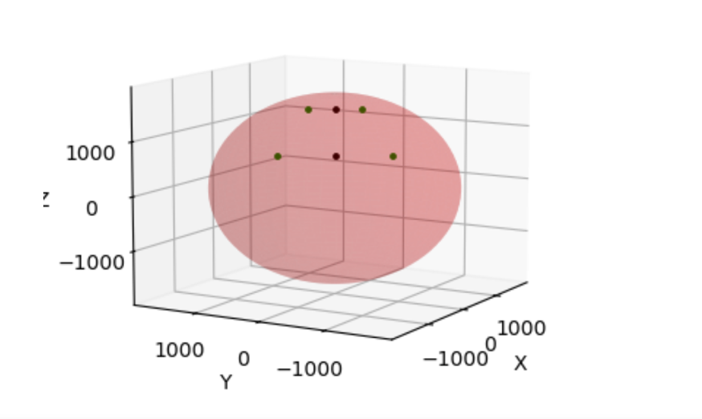

**Figure 1:** A 3D plot of the moon showing the location that image MC-02 corresponds to. The vertices of the image are in green, and the midpoint of the trapezium’s basesare in black.

a

b

h

To calculate the area represented by the images required the formula for the area of a trapezium [5] as seen in equation 3:

(3)

$$A_{surf}=\frac{a+b}{2} h ,$$

where $a$ and $b$ are the Euclidian length of the smaller and larger parallel bases respectively and $h$ is the Euclidian height of the trapezium. A visual representation of these variables can be seen in figure 1. The Euclidian distance, $d_{euc}$, in 3D space [6] between two points $\left(x_{1}, y_{1}, z_{1}\right)$ and $\left(x_{2}, y_{2}, z_{2}\right)$ is given by:

(4)

$$d_{euc}= \sqrt{{\left(x_{2}-x_{1}\right)}^{2}+{\left(y_{2}-y_{1}\right)}^{2}+{\left(z_{2}-z_{1}\right)}^{2}} .$$

To summarise how the crater frequency density could be calculated, the vertices of the images were converted from LL data to cartesian coordinates using equation 1. The Euclidian lengths and height of the trapezium were then calculated using equation 4, with the results being used in equation 3 to calculate the surface area of the image. Finally, equation 2 was then used to divide the number of craters in an image by the area of the image to give the crater density.

# Method

All the images used for this project can be seen in figure 2 as the source [7] provided relatively strong resolution images and the corners of the gridlines had the required LL data. Images from sections MC-01 and MC-30 were not included as their resolution was poor and the images appeared to be deformed stronger due to them being at the poles.

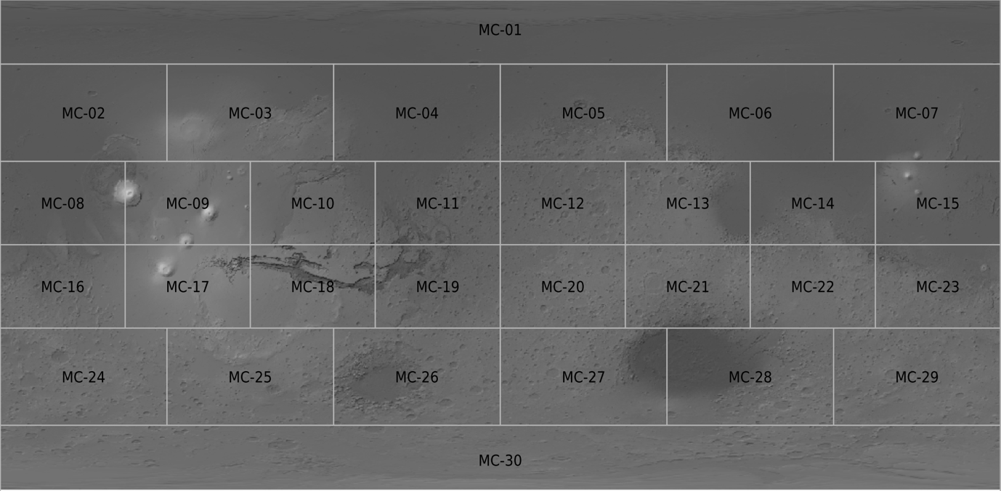

**Figure 2:** Image courtesy of Freie Universität Berlin [7]. This source provided the images and their corresponding LL data needed to determine $f_{dens}$ and therefore the age of each region.

The first step taken was to create an algorithm that could determine the number of craters within an image. To do so a python function known as Hough_Circles was implemented. This function identified circles within an image and assigned an accumulator value to each potential circle, the higher the value the more likely it deemed it a circle. This function had many parameters that required manually refining to improve its ability to identify craters from the specific images provided. Different images will require different parameter values for optimal detection, this depends on the lighting in the image the size of the circles and how bunched they amongst many other factors. The main five of these parameters were Min_Dist, Param1, Param2, Min_Radius and Max_Radius, a table explaining each of these parameters can be seen in figure 3.

|  |  |
| --- | --- |
| **Min_Dist** | The minimum distance between the centres of detected circles. If the parameter was too small, multiple neighbour circles may be falsely identified in addition to a true one. If it is too large, some circles may be missed. |
| **Param1** | Defines the threshold for the canny edge detector to determine an edge, value given is the upper threshold of pixel gradient canny uses to determine an edge. The lower threshold is taken as half the upper threshold value supplied. |
| **Param2** | The accumulator threshold the function used to determine whether something classifies as a circle. The smaller it is the more false circles will be detected due to noise. Circles corresponding to a larger accumulator value will be returned first as they are deemed more likely to be a circle. |
| **Min_Radius** | Minimum circle radius |
| **Max_Radius** | Maximum circle radius |

**Figure 3:** Documentation for the different parameters that the Hough Circles function used to identify circles.

Fine-tuning each of these parameters was an extensive task as it involved comparing plots side by side and judging how well it detected craters by eye. To simplify this task a graphical user interface (GUI) was created that allowed the user to change the parameters using sliders and see the effect on the number of craters detected. The GUI being used on one of the moon images can be seen in figure 4, in this figure the second image appeared blurrier as a median filter [8] had been applied to reduce noise and therefore improve edge detection. The disadvantage to applying this filter is some of the tiny craters get completely blurred out and therefore missed. The parameters were refined using this image until the algorithm appeared to detect $N$ as accurately as possible, it inevitably missed some craters and identified some false positives. The idea was that the combination of this overcounting and undercounting would balance, however this would never perfectly be the case.

**Figure 4:** A side by side of the original image (left) and the image after preprocessing and the crater detection algorithm had been applied (right).

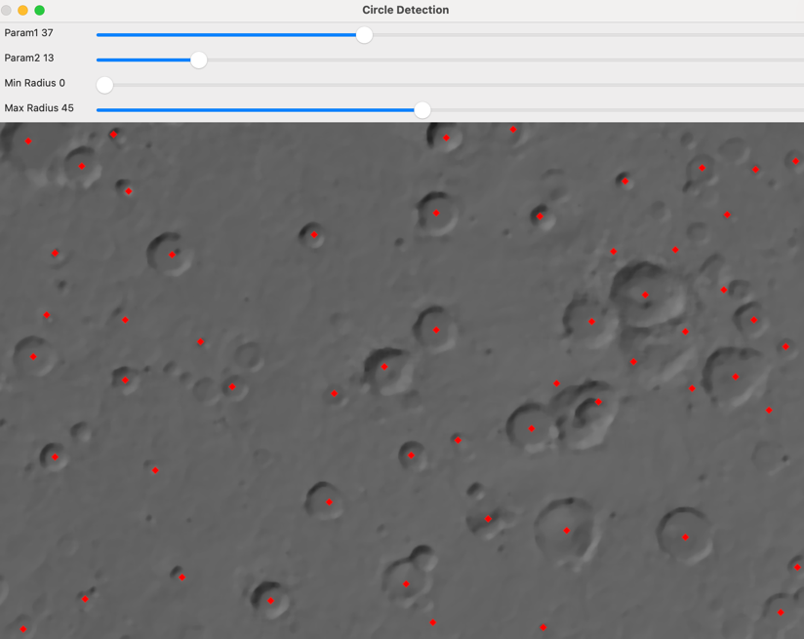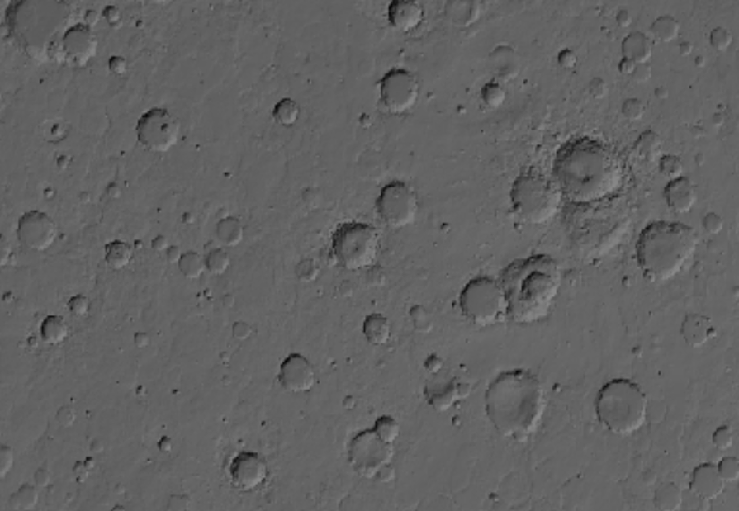

Once the ideal parameters were determined there needed to be a quantitative analysis of how accurate the function was at determining the number of craters in an image. To do so, several images were chosen at random and the number of craters in each image was counted manually, the values were then compared to the values determined by the algorithm to give a quantitative measure of the error in the function. The aim was to have an algorithm detection rate, $d_{r}$, that was around $80\%$ of the counted rates, it was desired to have a rate that was also consistent, i.e. a preferred range that $d_{r}$ varied between would between $75 – 85\%$ rather than fluctuating from $95\%$ one image and then $50\%$ the next. The process of counting the craters manually had its own error as it was hard to spot every crater and ensure that none had been double counted, especially when the images were large and contained over a hundred craters in some instances. To reduce this error, $N$ was counted by several different people for each test image and the average taken. Greater reduction in uncertainty could have been achieved by more repeats but this was a time extensive process and therefore a compromise had to be made. A threshold was placed on image-02 to to ease the process of crater counting by eye. This improved the contrast between the lighter and darker ridges with the grey of the Moon’s surface. The threshold removed the median greyscale value of the image, which resulted in the removal of the surface, and highlighted the lower and higher greyscale values of the image. This is shown by figure 5.

The final values for the parameters were Min_Dist = 35, Param1 = 30, Param2 = 3, Min_Radius = 0 and Max_Radius =50, which corresponded to a $d_{r}$ of $78\%$. Once the parameters had been refined such that the algorithm had a high consistent detection rate, it was used to determine the number of craters in 28 different images of the moon. The Hough_Circles function returned information about the pixel centre and the radius, $r$, for every circle detected, which enabled the cumulative frequency for each diameter value to be easily calculated. These 28 images mapped the entire surface of the moon (apart from the poles) as-well-as providing the relevant longitudinal and latitudinal (LL) data for all four corner pixels of each image.

**Figure 5:** The image seen in figure 4 after a threshold had been applied to improve the visibility of the craters.

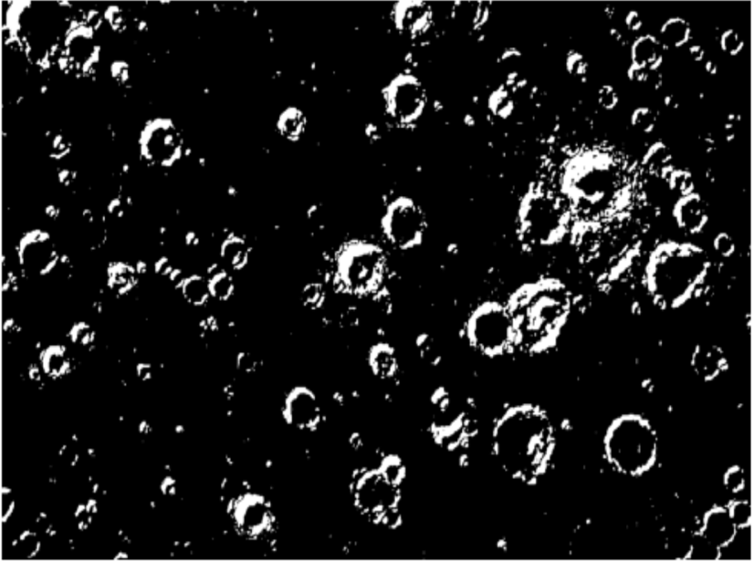

To sort the 3D array, obtained by Hough Circles, into ascending order of radius, the crater array had to be flattened to 2D and reordered to display the craters in order of ascending size. From this the $f_{dens}$ was calculated for each image using the process described in the theory section. There were two different areas, $A_{surf}$, for the images used, as images 2-7 and 24-29 had different dimensions to images 8-23, as seen in figure 3. Once the $f_{dens}$ values had all be calculated, their values could be read off figure 6 to give the age of the regions in Giga Annum ( ${10}^{9}$ years). This was done manually by eye for each image as there was not a formula for the function available, if there was our values could be plotted onto the function to more precisely read off the ages.

**Figure 6:** Image courtesy of Michael, G.G. and Neukum, G. [9]. The plot was used to determine the surface age in Giga-annums (Ga) given a Cumulative Crater Crater Frequency N(1) (km-2). This plot was produced from data of the surface of Mars.

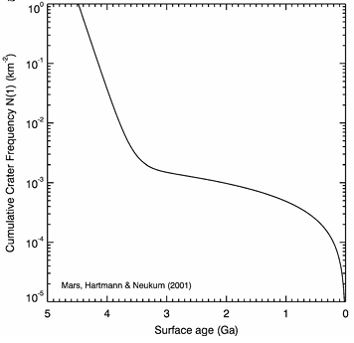

Once the ages of all the images were estimated, the LL data could be used to plot a 3D heat map of the moon and how its age varied across the surface.

# Results

Z (Km)

**Figure 7:** A 3D plot of the moon with the centres of each image plotted as blackdots.

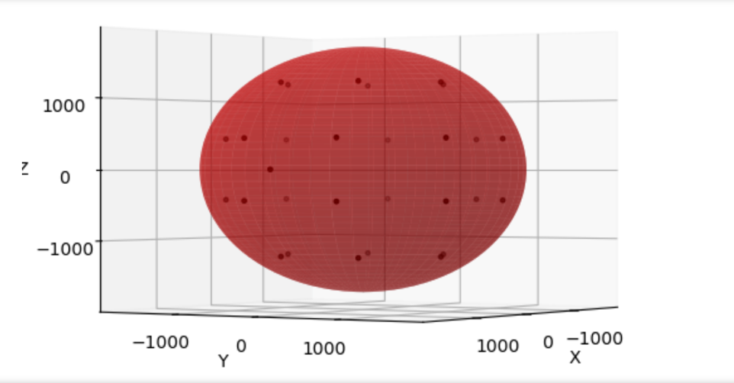

Y (Km)

X (Km)



Figure 7 gives a visual representation of where the images corresponded to on the 3D model of the moon, note there are no points at the top and bottom of the plot as no data was taken from regions MC-01 and MC-30 in figure 2 for reasons previously mentioned.

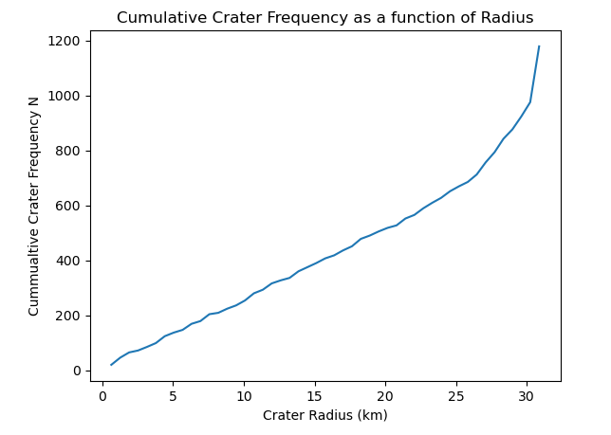

**Figure 8:**  A plot of the cumulative crater frequency as a function its radius in km. The distribution shows a spike in frequency at larger radii.

Figure 8 shows the cumulative crater frequency as a function of crater radius. This plot shows the distribution for image 02. Craters of radius close to 30km have a pixel radius of approximately 49 pixels.

The age of the surfaces in images MC-12,19 and 20 were calculated to be $\left(2.9 ±0.3\right)Ga$, $(3.1 ±0.3) Ga$ and $\left(3.0 ±0.3\right)Ga$ respectively. The average age of the moon across all images was $(2.9 ±0.3) Ga$, with the uncertainty determined by the standard deviation of the age data. The literature age of region MC-12, as determined from the physical rock samples, ranged from $(3.28 -3.91) Ga$ [10], [11], [12] with an average age of $3.59 Ga$. The literature age range for region MC-19 was $(3.17 -4.04) Ga$ [13], [14] with an average of $3.60 Ga$. The literature age range of region MC-20 was $(3.76 -3.90) Ga$ [15] with an average of $3.83 Ga$. Each individual rock sample had an uncertainty in its age on the order of ${10}^{-2} Ga$, however these uncertainties were not quoted as they were for the individual rock rather than the region it was found in.

The database on these three regions contained thousands of samples of rocks, whereas the averages were calculated from a limited sample of 5-10 per region. This was too small a sample to be reflective of the total population so just calculating the standard deviation or standard error for the sample would not be a representative uncertainty.

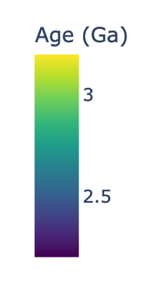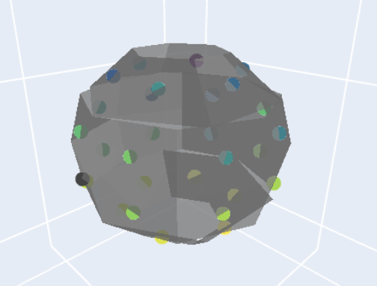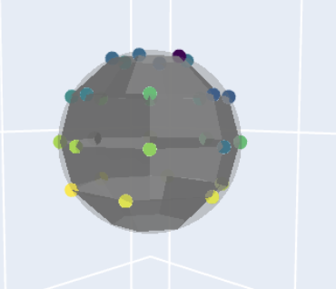

**Figure 9:** Snapshots of the interactive 3D heat map plot of the moon.

The image on the left of figure 9 plotted the moon split into 28 grey trapezia (corresponding to the 28 different images) with different colour circles plotted at the centre of each trapezium to indicate their age. The image on the right was similar to the left except the circles had been moved to the top left corner to display the trapezia shape easier, a feint grey sphere of radius R had also been plotted to indicate how the plot deferred from an ideal sphere.

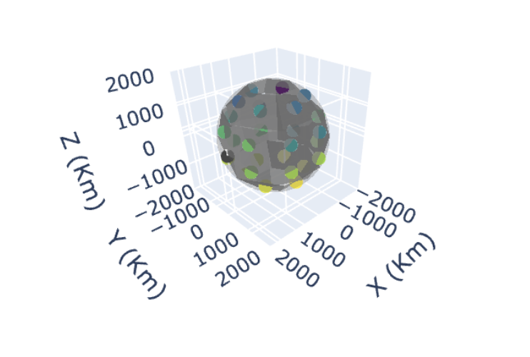

**Figure 10:** Similar plot to figure 9 except the axis are included to indicate the scale of the plot. The centre of the moon is at the origin of the reference frame.

# Discussion

Most heat maps appear to have a continuously varying regions, whereas the heat map, seen in figures 9 and 10, had relatively low detail as they were restricted to 28 discrete regions. This was due to the limited number of photos used and so to increase the detail, images could have been divided into smaller regions, by zooming in and splitting each of the 28 images into two or four smaller images. This would also increase the resolution in the original images leading to better crater detection, especially for the smallest craters. However, these images, and their corresponding LL data, were obtained manually so to do it for 120 images would take far too long for a two-week project. This would result in a better visualisation of the varying surface age of the moon.

The Hough Circles function proved effective in detecting circular edges, producing low noise from the edges of ridges that were clear in the central images. With a change in the minimum distance between each central crater detection, from 50 pixels to 35, a difference in the number of craters detected allowed us to obtain the surface age of the moon to a higher degree of accuracy. With 50 pixels an age around 200 million years was produced, which we know from the Apollo Lunar Missions was incorrect. From the adjustment to 35 pixels, it is possible to achieve a surface age consistent with experimental data produced from radiogenic age dating [10-15]. This was due to the higher cumulative frequency of craters obtained from detecting circles across a smaller interval of pixels. It should be noted that this may produce overlaps in detected craters, highlighting larger craters from their ridges twice.

Another factor that could have led to an incorrect crater detection rate was misidentifying different circular objects such as collapse pits, sublimation pits and volcanic calderas. If these were identified as impact craters, they would incorrectly inflate the CFD values and decrease the accuracy of the surface age estimations. If this project was longer, then a machine learning program could have been trained on images of craters and sublimation pits etc to ensure it could differentiate between them. Then when the Hough Circle algorithm detected a potential crater the machine learning program could filter out the non-impact crater circles.

When collecting data on the crater cumulative frequency density as a function of radius (shown in figure n), a spike in frequency can be seen at larger crater radii. This would be expected to continue if the maximum radius parameter of the Hough Circles function was increased. However, upon inspection of the images, the smaller craters are more dominant in comparison to the large. With the cut-off of maximum radius equivalent to 49 pixels, to increase this parameter would only increase the cumulative frequency by a negligible amount before the function starts to detect craters incorrectly.

When inferring the surface age of each image from figure 6, the error on the plot is high across regions of cumulative crater frequency 10-4 to 10-3km-2. As the curve tends towards a plateau within this region produces a high uncertainty when reading the age by eye, hence the large uncertainties quoted in the ages. Given further analysis, we could reproduce the plot and using Python extract an exact age for an input cumulative crater frequency density. This would reduce the human error on the surface age of each image.

The plot in figure n is the cumulative crater frequency density as a function surface age for Mars. This will result in inconsistencies with the determined age of the Moon surface. Factors such as atmospheric interference with incoming meteors/comets, as well as weathering processes may reduce the evident number of craters on Mars’ surface. The surface area difference between Mars and the Moon will also factor into the difference of the number of collisions Mars and the Moon will receive. Their relative position in the solar system could also affect the collision rate, as Mars is further out radially from the Sun, meteor or comet paths are deterred less by the gravitational influence of inner objects. The gravitational pull of Mars will also be higher than that of the moon and may cause a higher rate of in-falling objects. These factors alone will contribute to a different distribution of Cumulative crater frequency density as a function of surface age. A plot similar to figure n for the Moon could be produced to produce ages of the images to a higher accuracy.

# Conclusion

# References

[1] The Planetary Society, 2023. *Cost of Perseverance*. [online] Available at: <https://www.planetary.org/space-policy/cost-of-perseverance> [Accessed 1 November 2024].

[2] Basilevsky, A.T. and Head, J.W., 2003. The surface of Venus. *Reports on Progress in Physics*, *66*(10), p.1699.

[3] Soler, T., 1976. *On differential transformations between Cartesian and curvilinear (geodetic) coordinates* (No. REPT-236).

[4] Kopal, Z., 1967. The shape of the Moon, its internal structure and moments of inertia. *Proceedings of the Royal Society of London. Series A. Mathematical and Physical Sciences*, *296*(1446), pp.254-265.

[5] Morrison, K., Smith, J., McLean, P., Asker, N. and Horsman, R., 2015. *GCSE Mathematics for Edexcel Higher Student Book*. Cambridge University Press.

[6] Parhizkar, R., 2013. *Euclidean distance matrices: Properties, algorithms and applications* (No. 5971). EPFL.

[7] Freie Universität Berlin, 2023. *Mars Global Map by Freie Universität Berlin’s Planetary Science and Remote Sensing Group*. [online] Available at: <https://maps.planet.fu-berlin.de/#map=3/-4927825.8/-2600105.93> [Accessed 1 November 20]

[8] Torre, V. and Poggio, T.A., 1986. On edge detection. *IEEE Transactions on Pattern Analysis and Machine Intelligence*, (2), pp.147-163.

[9] Michael, G.G. and Neukum, G., 2010. Planetary surface dating from crater size–frequency distribution measurements: Partial resurfacing events and statistical age uncertainty. *Earth and Planetary Science Letters*, *294*(3-4), pp.223-229.

[10] *Lunar Sample Atlas* (2024), Item 10020*.* Lunar and Planetary Institute. [Database]. Available at:

<https://www.lpi.usra.edu/lunar/samples/atlas/> (Accessed: 7 November 2024).

[11] *Lunar Sample Atlas* (2024), Item 15065. Lunar and Planetary Institute*.* [Database]. Available at: <https://www.lpi.usra.edu/lunar/samples/atlas/> (Accessed: 7 November 2024).

[12] *Lunar Sample Atlas* (2024), Item 70035. Lunar and Planetary Institute*.* [Database]. Available at: <https://www.lpi.usra.edu/lunar/samples/atlas/> (Accessed: 7 November 2024).

[13] *Lunar Sample Atlas* (2024), Item 12009. Lunar and Planetary Institute*.* [Database]. Available at: <https://www.lpi.usra.edu/lunar/samples/atlas/> (Accessed: 7 November 2024).

[14] *Lunar Sample Atlas* (2024), Item 14072. Lunar and Planetary Institute*.* [Database]. Available at: <https://www.lpi.usra.edu/lunar/samples/atlas/> (Accessed: 7 November 2024).

[15] *Lunar Sample Atlas* (2024), Item 67559. Lunar and Planetary Institute*.* [Database]. Available at: <https://www.lpi.usra.edu/lunar/samples/atlas/> (Accessed: 7 November 2024).

[y] Barboni, M., Boehnke, P., Keller, B., Kohl, I.E., Schoene, B., Young, E.D. and McKeegan, K.D., 2017. Early formation of the Moon 4.51 billion years ago. *Science advances*, *3*(1), p.e1602365.

# Appendix

**Information on the interactive plot and instructions on how to check which grey ‘rectangle’ corresponded to which image.**

The 2D map of the moon seen in figure 4 is divided into sections as seen. Only 28 of the regions (MC-02 to MC–29) were included in the interactive plot and these are named trace1 – trace28 when you hover the mouse over them.